

PYTHON PROGRAMMING
PROJECT FILE

BHADERWAH CAMPUS, UNIVERSITY OF JAMMU

PRACTICAL FILE
BASED ON
“PYTHON PROGRAMMING”
BCA (DATA SCIENCE)



SUBMITTED TO BHADERWAH CAMPUS, UNIVERSITY OF JAMMU FOR THE PARTIAL FULFILLMENT OF THE AWARD OF ^{BCA-7th} SEMESTER.

SUBMITTED TO:- SUBMITTED BY:-
Dr. ASHOK SHARMA Intiza Shafayat
I/C HEAD UNIVERSITY ROLL NO.
DEPT. OF CS & IT 713040004 H

SIGN.......................

DEPARTMENT OF COMPUTER SCIENCE & IT
CERTIFICATE

This is to certify that Ms. Intiza Shafayat, a student enrolled in the BCA 7th semester under university roll number 713040004 at the Bhaderwah Campus, University of Jammu, has successfully completed the Practical File during the session. This accomplishment contributes towards the partial fulfilment of credits for the "Python Programming" practical course.

Ms. Intiza Shafayat has submitted a satisfactory report, as compiled in the following pages, under my diligent supervision.

PRACTICAL INCHARGE
Ms. JAHANVI KOTWAL

SIGN__________________

COURSE COORDINATOR

SIGN__________________

Acknowledgement

I would like to express my heartfelt appreciation for the invaluable support and guidance that played a crucial role in the successful completion of this practical file.
I extend my deepest thanks to Ms. Jahanvi Kotwal, our dedicated Python Programming teacher, whose expertise and encouragement have been instrumental in elevating my understanding of programming concepts. His unwavering guidance and supervision have transformed this practical file into a truly meaningful learning experience.
In addition to recognizing Ms. Jahanvi Kotwal contribution, I want to highlight the self-driven effort I invested in this project. Undertaking such a task was both challenging and rewarding, allowing me to not only solidify my programming skills but also enhance my problem-solving abilities.
While this project predominantly represents an individual effort, it is essential to acknowledge the dynamic learning community that surrounds me. The exchange of ideas and the supportive environment within this community have significantly contributed to shaping my approach to this practical file.
In conclusion, my gratitude extends to Ms. Jahanvi Kotwal and the entire learning community for their inspiration and unwavering support. This practical file serves as a testament to the dedication and commitment invested in the relentless pursuit of knowledge.

Thank you for being an integral part of this enriching journey.

INDEX
01 | Write a program to find sum of digits of number.
02 | Write a program to demonstrate string concatenation.
03 | Write a program to find reverse of a number.
04 | Write a program to calculate simple interest.
05 | Write a program to check whether the number entered is Armstrong number or not.
06 | Write a program to prompt a user to enter a day of the week. If the entered day of the week is between 1 and 7 then display the respective name of the day.
07 | Write a program to display the pattern.  * * * * *  * * * *  * * *  * *  *
08 |  | Demonstrate the use of following inbuilt functions with lists (i)Len () (ii) max () (iii) min () (iv) sum () (v) random-shuffle ( ).
09 |  | Demonstrate the following list manipulation methods in Python with suitable examples: (i) append () (ii) clear () (iii)count () (ix) sort () (x) copy () (xi) clear () (xii) extend () (iv) copy () (v) extend () (vi) insert () (vii) pop () (viii)remove.
10 |  | Write a program using while loop to print factorial of a number.
11 |  | Demonstrate the use of list slicing using suitable examples.
12 |  | Write a program to count words/line in a file.
13 |  | Write a python program to create a class student and print the details of a student.
14 |  | Write a program to show how encapsulation works using private variables.
15 |  | Write a program to implement abstraction using ABC (Abstract Bases Class).

1.1:- Write a program to find sum of digits of number.

def get Sum(n):
sum = 0
for digit in str(n):
sum += int(digit)
return sum
n = 12345
print (get Sum(n))

output:-

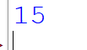

1.2:- Write a program to demonstrate string concatenation.

string1 = "Hello"

string2 = "MYSTICAL DIMPPLE"

result = string1 + " " + string2

print(result)

output:-

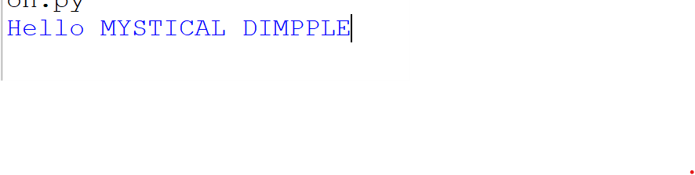

1.3:-Write a program to find reverse of a number.

num = 45678
reversed _num = 0
while num! = 0:
digit = num % 10
reversed _num = reversed _num * 10 + digit
num //= 10
print ("Reversed Number:", reversed _num)

output:-

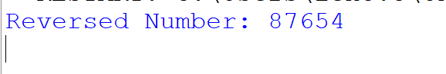

1.4:- Write a program to calculate simple interest.

def simple_ interest (p, t, r):
print ('The principal is', p)
print ('The time period is', t)
print ('The rate of interest is', r)
s_ I = (p * t * r) / 100
print ('The Simple Interest is', s_ I)
return s_ I
simple_ interest (20000, 6, 6)

output:-

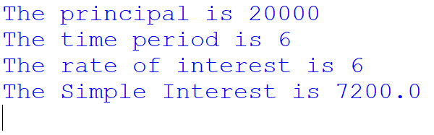

1.5:- Write a program to check whether the number entered is Armstrong number or not.

num = int (input ("Enter a number: "))
sum = 0
temp = num
while temp > 0:
digit = temp % 10
sum += digit ** 3
temp //= 10
if num == sum:
print(f"{num} is an Armstrong number")
else:
print(f"{num} is not an Armstrong number")

output:-

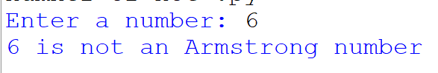

1.6:-Write a program to prompt a user to enter a day of the week. If the entered day of the week is between 1 and 7 then display the respective name of the day.
a= input ("Enter a number between 1and 7 ")
if a=='1':
print("MONDAY")
Elif a=='2':
print("TUESDAY")
Elif a=='3':
print("WEDNESDAY")
Elif a=='5':
print("FRIDAY")
Elif a=='6':
print("SATURDAY")
Elif a=='7':
print("SUNDAY")
else:
print ("wrong input ")
Elif a=='4':
print("THURSDAY")
output:-
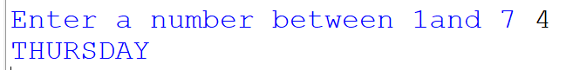

1.7:-Write a program to display the pattern.

* * * * *
* * * *
* * *
* *
*
rows = 5
for i in range (rows, 0, -1):
for j in range (0, i):
print ("*", end=" ")
print ()

output:-
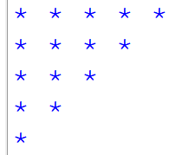

1.8:-Demonstrate the use of following inbuilt functions with lists (i)len() (ii) max () (iii) min () (iv) sum ( ) (v) random-shuffle ( ).
List = [1, 2, 3, 1, 3, 1, 4, 3, 6, 1]
Print (Len (List))
numbers = [5, 9, 8, 8, 6]
print(min(numbers))
numbers = [5, 2, 8, 6, 8]
print(max(numbers))
List = [1, 2, 7, 4, 6]
Print (sum (List))

output:-
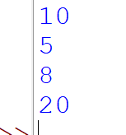

1.9:-Demonstrate the following list manipulation methods in Python with suitable examples: (i) append ( )(ii) clear ( ) (iii)count () (ix) sort () (x) copy ( ) (xi) clear ( ) (xii) extend ( ) count ( ) (iv) copy ( ) (v) extend ( ) (vi) insert ( ) (vii) pop ( ) (viii)remove.
List = ['Mathematics', 'chemistry', 1997, 2000]
List. Append (20544)
Print (List)
List = [1, 2, 3, 1, 2, 1, 2, 3, 2, 1]
Print (List. Count (1))
List = [2.3, 4.445, 3, 5.33, 1.054, 2.5]
Print (List. Pop ())
List = [2.3, 4.445, 3, 5.33, 1.054, 2.5]
List. Remove (3)
Print (List)
List = [2.3, 4.445, 3, 5.33, 1.054, 2.5]
List. sort(reverse=True)
Print (List)
List1 = [1, 2, 3]
List2 = [2, 3, 4, 5]
List1.extend(List2)
Print (List1) List2.extend(List1)
Print (List2)
List = ['Mathematics', 'chemistry', 1997, 2000]
List. Insert (2, 10087)
Print (List)
import copy
li1 = [1, 2, [3, 5], 4]
li2 = copy. copy(li1)
print ("li2 ID: ", id(li2), "Value: ", li2)
li3 = copy. Deep copy(li1)
print ("li3 ID: ", id(li3), "Value: ", li3)
Lis = [1, 2, 3]
Lis. Clear ()
Print (Lis)
output:-

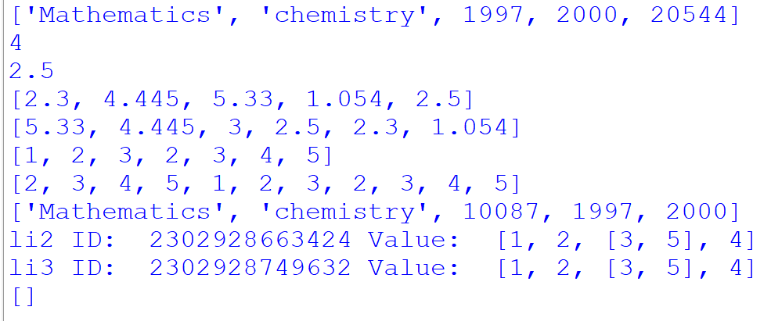

10:-Write a program using while loop to print factorial of a number.

def factorial_ while(n):
"""Calculate factorial of a non-negative integer using a while loop."""
if n < 0:
raise Value Error ("Factorial is not defined for negative numbers.")
result = 1
counter = 1
while counter <= n:
result *= counter
counter += 1
return result
try:
num_ str = input ("Enter a non-negative integer: "). Strip ()
if not num _str. Is digit ():
raise Value Error ("Invalid input. Please enter a non-negative integer.")
num = int (num_ str)
fact = factorial_ while(num)
print (f" Factorial of {num} is: {fact}")
except Value Error as e:
print ("Error:", e)
output:-

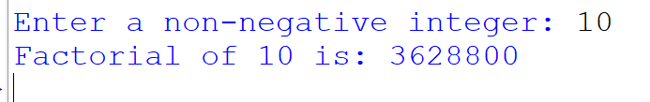
11:-Demonstrate the use of list slicing using suitable examples.

My _list = [1, 2, 3, 4, 5, 6, 7, 8, 9, 10]
slice1 = my _list [2:5]
print(slice1)
slice2 = my _ list [:6]
print(slice2)
slice3 = my _ list [3:]
print(slice3)
output:-
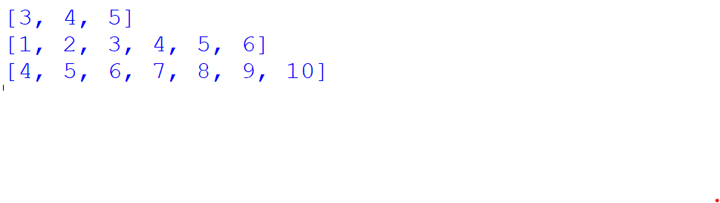

12:- Write a program to count words/line in a file.

def count_ words_ lines (file _path):
"""
Counts the number of lines and words in the given file.
: param file _path: Path to the file
: return: tuple (line _count, word _count)
"""
try:
with open (file _path, 'r', encoding='utf-8') as file:
line _count = 0
word _count = 0

for line in file:
line _count += 1

words = line. Split ()
word _count += len (words)

return line _count, word _count
except File Not Found Error:
print (f" Error: File '{file _path}' not found.")
return None, None
except Permission Error:
print (f" Error: Permission denied to read '{file _path}'.")
return None, None
except Exception as e:
print (f" An unexpected error occurred: {e}")
return None, None
if __name__ == "__main__":

file_ path = input ("Enter the file path: "). Strip ()

lines, words = count _words_ lines (file _path)

if lines Is not None:
print (f" Total Lines: {lines}")
print (f" Total Words: {words}")

output:-
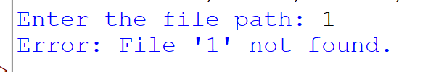

13:- Write a python program to create a class student and print the details of a student.

class Student:
def __Init_ (self, roll _no: int, name: str, marks: float):

if not is instance (roll _no, int) or roll _no <= 0:
raise Value Error ("Roll number must be a positive integer.")

if not name. strip ():
raise Value Error ("Name cannot be empty.")

if not (0 <= marks <= 100):
raise Value Error ("Marks must be between 0 and 100.")

self. roll_ no = roll_ no
self. name = name. strip ()
self. Marks = marks

def display_ details(self):
"""Prints the student details in a formatted way."""
Print ("\n--- Student Details ---")
Print (f" Roll Number: {self. roll_ no}")
Print (f" Name: {self.name}")
Print (f" Marks: {self. Marks:.2f}")
if __name__ == "__main__":
try:
roll _no = int (input ("Enter Roll Number: "))
name = input ("Enter Name: ")
marks = float (input ("Enter Marks (0-100): "))

student = Student (roll _no, name, marks)
student. display_ details ()
except Value Error as e:
print (f" Error: {e}")
except Exception as e:
print (f" Unexpected error: {e}")

output:-

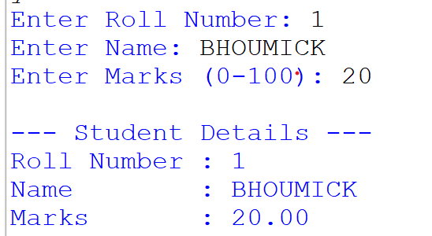

14:- Write a program to show how encapsulation works using private variables.

class Employee:
def __Init (self, name, salary):
self.name = name
Self _Salary = None
self. set_ salary(salary)
def get _salary(self):
return Self_ Salary
def set _salary (self, salary):
if not is instance (salary, (int, float)):
raise Value Error ("Salary must be a number.")
if salary < 0:
raise Value Error ("Salary cannot be negative.")
Self. salary = salary
def display _info(self):
print (f" Name: {self.name}")
print (f" Salary: ₹ {self _salary}")
try:
emp = Employee ("John Doe", 50000)
print ("Public attribute (name):", emp.name)
print ("Private attribute (salary) via getter:", emp. Get _ salary ())

emp. Set _salary (60000)
print ("Updated salary via getter:", emp. Get _salary ())
emp. Display _info ()
except Exception as e:
print ("Error:", e)

output:-

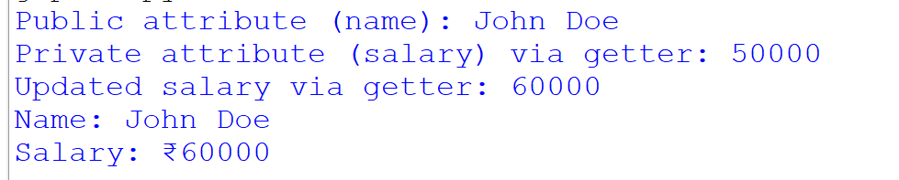

15:- Write a program to implement abstraction using ABC (Abstract Bases Class).

from ABC import ABC, abstract method
class Shape (ABC):
"""
Abstract base class representing a geometric shape.
All shapes must implement the area () and perimeter () methods.
"""
@abstractmethod
def area(self):
"""Calculate and return the area of the shape."""
pass
@abstractmethod
def perimeter(self):
"""Calculate and return the perimeter of the shape."""
pass
class Circle (Shape):
def __ Init __ (self, radius):
if radius <= 0:
raise Value Error ("Radius must be positive.")
self. Radius = radius
def area(self):
from math import pi
return pi * self. radius ** 2
def perimeter(self):
from math import pi
return 2 * pi * self. radius
class Rectangle (Shape):
def __ Init __ (self, length, width):
if length <= 0 or width <= 0:

raise Value Error ("Length and width must be positive.")
self. length = length
self. Width = width
def area(self):
return self. length * self. width

def perimeter(self):
return 2 * (self. length + self. width)
if __name__ == "__main__":
try:
print ("Choose shape: 1. Circle 2. Rectangle")
choice = input ("Enter choice (1/2): "). Strip ()

if choice == "1":
radius = float (input ("Enter radius: "))
shape = Circle(radius)
Elif choice == "2":
length = float (input ("Enter length: "))
width = float (input ("Enter width: "))
shape = Rectangle (length, width)
else:
raise Value Error ("Invalid choice.")

print (f" Area: {shape. Area ():.2f}")
print (f" Perimeter: {shape. perimeter ():.2f}")

except Value Error as e:
print (f" Error: {e}")
except Exception as e:
print (f" Unexpected error: {e}")

output:-

